Naveen Kumar Buddhala (001582394)

**Program Structures & Algorithms**

**Spring 2021**

**Assignment No. 3**

**Task**

**Height-Weighted Quick Union with Path Compression** – to deduce a relationship between the number of objects(n) and the number of pairs(m) generated to reduce the number of components from n to 1.

**Output**

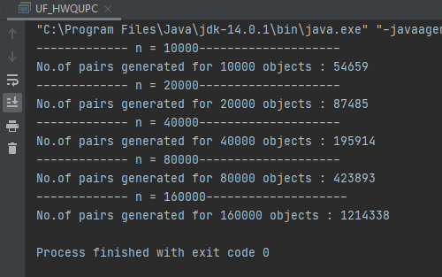

**Relationship Conclusion**

Out of 5 random experiments – for every value of n– no. of pairs generated (m), we derived

$$m ∞ \frac{1}{2} n\log{n}$$

**Evidence to support**

|  |  |  |
| --- | --- | --- |
| No of objects (n) | No of pairs generated (m) | $$\frac{1}{2}n\log{n}$$ |
| 10000 | 54659 | 66438.5619 |
| 20000 | 87485 | 142877.1238 |
| 40000 | 195914 | 305754.2476 |
| 80000 | 423893 | 651508.4952 |
| 160000 | 1214338 | 1383016.99 |

As we compare the values with the $\frac{1}{2}n\log{n}$ graph we find them similar.

Also, we know that the no. of pairs generated(m) is always 1 when the no. of objects(n) are 2, which fits well in the above equation

$\frac{1}{2}*2*\log{2}=1$, hence proving our equation.

**Unit Test**

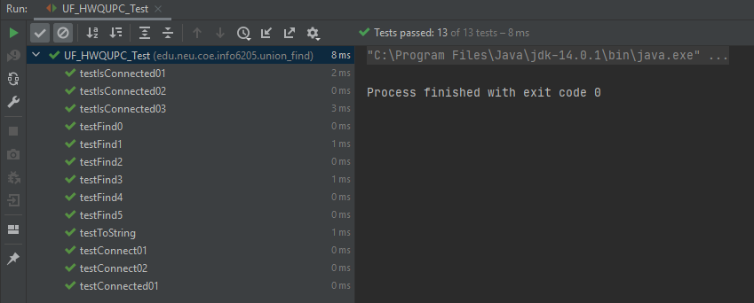**UF_HWQUPC_Test -**